**Question 1 : - 2012**

Describe five groups of consumer in relation to the technology adoption life cycle

Draw a graph depicting the technology adoption cycle showing

* The position and appropriate size of each group in relation to one another
* The name and a short explanation for each group of consumers.

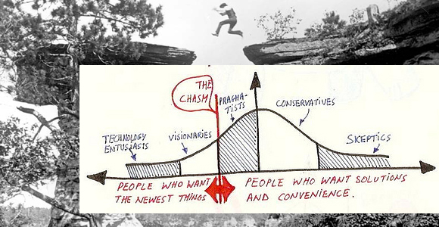

* **Innovators** – Technology Enthusiasts
  + People who are enthusiastic about the product and want to be the first to try it.
* **Early Adopters – Visionaries**
* **Early Majority** – Pragmatists
  + Open to ideas and active in the community,
* **Late Majority** - Conservatives
  + wait for the benefits to clearly be identified and widely used before adopting
* **Laggards** – Skeptics
  + very conservative, small ventures, low capital.

**Question 1B – 2012**

**What is meant by crossing the chasm?**

According to Moore, the marketer should focus on one group of customers at a time, using each group as a base for marketing to the next group. The most difficult step is making the transition between visionaries (early adopters) and pragmatists (early majority)

**Identify the challenges face by the transition between each of the five groups of consumers**

* Each group needs to be targeted one at a time as a market basis for the next group - Can’t quickly go through all of the 5 groups. Need to focus on one as the basis for the next.
* The chasm between early adopters, and early main stream can be difficult to cross - The rush of **early adopters slows down** and **sales getting tougher –** need to keep momentum built up.

**Include examples to illustrate these challenges. – The high school dance problem**

Boys are standing around the room, and girls are in the centre dancing.

The girls are the product managers in this scenario, and the boys are the customers. The market pain is getting the dance started. The girls have the challenge of finding the first boy (customer) that is willing to participate. This will be the enthusiasts that want to dance but haven’t been offer the product.

**Facebook** – Initial started on a single campus.

**Question 2A – 2012**

**Define the term Market -** A market is a group of customers who have the same pain, money, and talk to each other.

**Importance in relation to technology innovation.**

* Where product will be defined and released - Has to suit this market and solve that pain.
* Determines if the product and pain it solves is large enough to generate a profit
* If it’s a mature market, then you have to push something out to get a foot in. e.g small innovations.
* Small innovations can be better than reinventing the wheel.

**Question 2B**

Product manager & project manager

**A Project Manager is like a mid wife- he/she delivers the baby, hands it over to the mother and moves on. The baby being the product and the mother being the Product Manager** – Derek Morrison

**Product management – External Methodology - Lean**

* Product owner - Decides what they made
* Sets up, defines, and overseas the entire life cycle.
* Uses the product – and channel ( direct/ indirect sales) – effectively selling the product.

**Project management – Internal Methodology – Agile – More technical**

* In charge of resources
* Managing development team
* More time in the field with the customer generating requirements

**Comparison**:

* Share the same objective – success in the market
* Share much of the same data, many of the same sources, contribute to each others information and intelligence sources.

**Question 2C – 2012**

**Semi structured interview** – What we did with the product managers. A brief set of questions intended to provide talking points to receive more detailed information.

**Advantages**

* Get the information you want from the original questions and expanding out to ideas outside the realm of what you expected – further insight
* Interviewee is less under pressure to answer a set of questions, natural progression through questions like a conversation – allowing addition questions to be added or removed.

**Disadvantages –**

* Questions are vague and don’t get the response you want – Poor quality Questions could give poor quality answers
* Tangents in the conversation that waste time – the conversation becoming derailed.

**Question 2 D – 2012**

Software can be delivered in different ways. Name and describe three modes of software delivery

**Software as a service**

* Client does not get to choose product. Allows developers to decide where to go with the product resulting in specialised products.
* Sign up and start consuming. No upfront investment, available in public cloud, scalable.

**Single tenant** ( remotely hosted ) big , conservative banks, **multi-tennant** ( cloud) hotel owners.

**Software as a product**

* Traditional model for software delivery. Develop it, and sell licenses
* One license per machine.
* Best suited to annual releases such as Anti virus packages.

**Freemium**

* Try before you buy
* Paying customers support free customers
* Tiered pricing service / function thresholds.
* Spreads by positive word of mouth – e.g. Dropbox

**Question 3 a – 2012**

**Explain why a market score sheet is used?**

A market score sheet is used to determine the position of the product both internally and externally and is used to determine if there is a gap in the understanding of the market.

* User stories or requirements are scored using both an internal and external scores
* Internal is the engineering team, with external being the client
* Large discrepancies between internal and external shows you don’t understand your market and more market research is needed.
* Used to make a go/no go statement.

**Question 3 ii – 2012**

What happens once a score sheet has been produced

Once it has been produced it is what

* You can use to build your proposition
* Highlights key features for your elevator pitch
* Shift focus to produce a better MVP
* Identifies areas that need more market research.
* Determine if the product is go/no go.